Operational Concept Description (OCD)

<Project Name>

<Team number>

<Team members and roles>

<Date>

Version History
Date | Author | Version | Changes made | Rationale
08/20/05 | PP | 1.0 | - Original template for use with LeanMBASE v1.0 | - Initial draft for use with LeanMBASE v1.0
08/28/05 | PP | 1.1 | - Added section 3.2 | - Section 3.2 was added to provide traceability for the outcome in the Benefits Chain
08/30/06 | SK, RT | 1.6 | - Added Template for Tables and Figures | - Consistent format
10/04/06 | SK | 1.61 | - Added section 3.3.1 | - Section 3.3.4
09/14/07 | SK | 1.9 | - Updated Section 2.4, 3.3.1, 3.3.2, 3.3.3 | - Consistent with LeanMBASE V1.9
08/25/08 | PA | 2.0 | - Swapped sections 3.4 and 3.5.  - Renamed section 2.4 title from “Benefits Chain (Initiatives, Expected Outcomes, and Assumptions)” to “Benefits Chain”  - Replaced References section (1.2) with “Status of the OCD”  - Edited Table 1 structure to be consistent with the Instructional ICM-Sw OCD Guideline.  - Added Figure 2, Figure 3, and Figure 4  - Edited Table 2 to be consistent with the Instructional ICM-Sw OCD Guideline | - Initial draft for use with Instructional ICM-Sw v2.0 modified from LeanMBASE v1.9
05/22/09 | SK | 2.1 | - Embedded description in each Table  - Removed Section 3.5 Prototype  - Moved all goals to the Section 3.1  - Added Constraints to Section 3.1  - Removed Section 4. WikiWinWin Result  - Added Section 3.1 Current System | - To be consistent with ICM EPG template set standard V2.1  - Moved Prototype information to Prototype report  - To document information about current system

Table of Contents
Operational Concept Description (OCD) i
Version History ii
Table of Contents iii
Table of Tables iv
Table of Figures v
1. Introduction 1
1.1 Purpose of the OCD 1
1.2 Status of the OCD 1
2. Shared Vision 2
2.1 Success-Critical Stakeholders 2
2.2 System Capability Description 2
2.3 Expected Benefits 2
2.4 Benefits Chain 3
2.5 System Boundary and Environment 5
3. System Transformation 6
3.1 System Objectives, Constraints and Priorities 6
3.2 Proposed New Operational Concept 8
3.3 Organizational and Operational Implications 11

Table of Tables
Table 1: Success-Critical Stakeholders 2
Table 3: Level of Service Goals 6
Table 2: Relation to Current System 8

Table of Figures
Figure 1: Benefits Chain Diagram of Volunteer Tracking System 4
Figure 2: Benefits Chain Diagram 4
Figure 3: System Boundary and Environment Diagram of Volunteer Tracking System 5
Figure 4: System Boundary and Environment Diagram 5
Figure 5: Element Relationship Diagram of Volunteer Tracking System 9
Figure 6: Element Relationship Diagram 9
Figure 7: Business Workflow Diagram of Volunteer Tracking System 10
Figure 8: Business Workflows Diagram 11

Introduction

Purpose of the OCD
<<Identify the objectives of this document, brief information about your success critical stakeholders’ name and organization. For example:

“This document provides, in detail, the shared visions and goals of the stakeholders of the Volunteer Tracking System for the California Science Center (CSC). The success-critical stakeholders of the project are Jeremy Stoller, as the project owner; the CSC Staff and volunteers, as users; Vincent Tsan, as the maintainer.” >>

Status of the OCD
<<Briefly describe about status of this document, key differences from previous version, and related open issues that has not been resolved. For example:

“The status of the OCD is currently at the As-Built version number 9.4 in the development phase. The scope of the Volunteer Tracking System project has been re-evaluated to accommodate those challenges by removing the core capability of certificate generation. Vincent Tsan has been assigned to be the maintainer.” >>

Shared Vision

Success-Critical Stakeholders
<< Identify all success critical stakeholders, their organizations and how they relate to this project. Common success critical stakeholders are client, user, maintainer, development team, and IIV&Ver. You can use the following table to list all the success critical stakeholders. >>
Table 1: Success-Critical Stakeholders
Stakeholder | Authorized Representatives | Organization | Relation to Benefits Chain
Client | Jeremy Stoller | California Science Center (CSC) | - Provide information and feedback to the development team.  - Use the system  - Provide training to the future user.
Volunteer | N/A: anybody who applies to volunteer at CSC | California Science Center (CSC) | - Submit application online  - Clock in/out online
…….

System Capability Description
<< Provide an “elevator test” summary of the project's expected benefits, i.e., a short executive summary that could convince a potential funder (venture capitalist) “during the course of a short elevator ride.” (See Geoffrey Moore's Crossing the Chasm (Harper Collins, 1991, p.161)). Such an “elevator test” summary includes:
- The type of system to be built
- The target customer(s) for the system
- The need or opportunity that will be satisfied by the system
- A compelling reason for the customer to buy/use the system
- The closest competitor of the system
- The system's primary differentiation from, or benefit over, the closest competitor or alternative approach, if there are competitors or alternatives ah the time >>

Expected Benefits
<< Identify the potential benefits of the system that you are developing. Please note that an expected benefit is different from project goals and it is not a system capability. The expected benefits developed in this section serve as a starting point for creating the benefits chain in the next section.
Examples of expected benefits are:
- The supervisors will spend less time dealing with the volunteers; thus, increasing productivity in their other areas of work.
- Volunteer candidates can fill out the application online and information will be automatically stored in the database. >>

Benefits Chain
<< The benefits chain diagram illustrates the following information
- Stakeholder(s): What are the success critical stakeholders who create and receive benefits from the developing system? E.g. Development team, Volunteer, Manager
- Initiative: What are the actions that stakeholder(s) performs that could contribute benefit to the system. Initiative should be represented in Verb-form. E.g. Develop automatic report generation module, fill out online application, Analyze volunteer performance
- Contribution: What are the results of the initiative that will add to the benefits to the system? E.g. automated report generation process, paperless application, insightful volunteer performance analysis
- Outcome: Benefits that is contributed by the system such as improved volunteer management performance, faster application processing
- Assumption: What are the conditions that have to be true in order to make this benefit chain to be true.

Below is an example and a template of Benefit Chain Diagram: >>

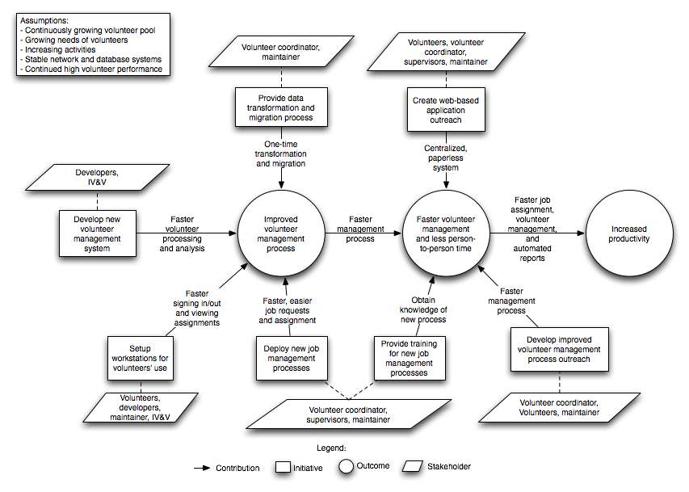
Figure 1: Benefits Chain Diagram of Volunteer Tracking System

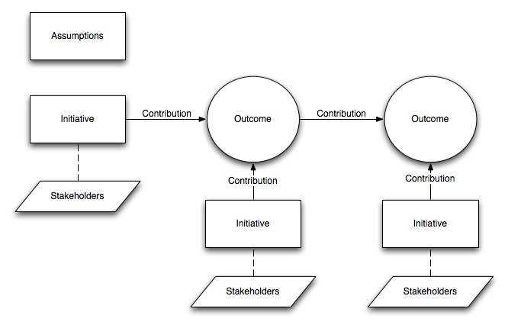
Figure 2: Benefits Chain Diagram

System Boundary and Environment
<< The system boundary and environment diagram contains a list of services and functions that the project team will be responsible for developing and delivering, as well as the system environment showing the stakeholders' organizations and other systems for which the project has no authority or responsibility, but with which the delivered system must interface in order to deliver the desired benefits. The figure below shows the basic structure context diagram used to define the system boundary. Below is an example and a template of a system boundary and environment diagram.>>
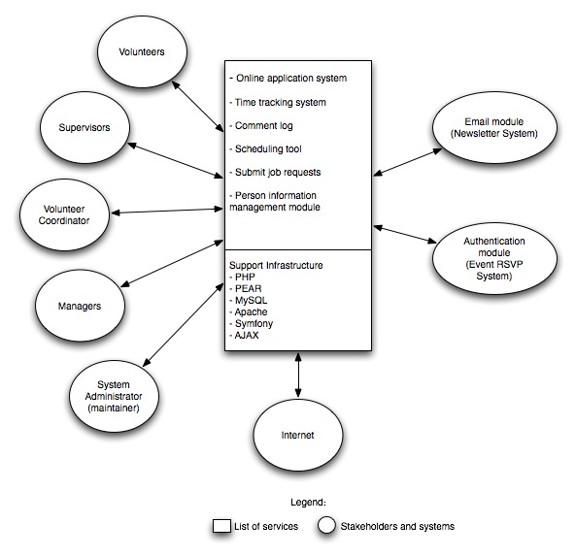
Figure 3: System Boundary and Environment Diagram of Volunteer Tracking System

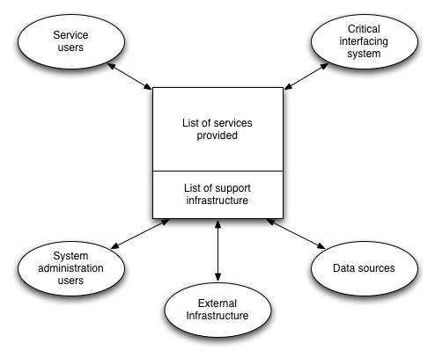
Figure 4: System Boundary and Environment Diagram

System Transformation

Information on Current System

Infrastructure
<< Describe the infrastructure currently utilized at the client’s organization, such as hardware, software, and network. >>

Artifacts
<< List the artifacts used by the system or by the users in operating the system. Provide a brief description about each artifact. >>

Current Business Workflow
<< Sketch the overview of business workflows around the current system. Use an activity diagram to describe business workflow. >>

System Objectives, Constraints and Priorities

Capability Goals
<< Provide a brief enumeration of the most important operational capability goals. A “capability” is simply a function or set of functions that the system performs or enables users to perform. To facilitate traceability between capability goals listed in the OCD and references to them from other artifacts (SSAD, LCP, and FED), assign each capability a unique designation (e.g. OC-1) and a short descriptive name.
Capability Goals | Priority Level
<< OC-1 Automated Report Generation: The system is capable of generating the report in PDF format. >> | << Must have>>

Level of Service Goals
<< Identify in a table the desired and acceptable goals for the proposed new system's important levels of service. >>
Table 2: Level of Service Goals
Level of Service Goals | Priority Level
<< LOS-1: Concurrent users: The system shall allow at least 50 concurrent users to use the system. >> | <<Must have>>

Organizational Goals
<< List briefly the broad, high-level objectives and aspirations of the sponsoring organization(s) and any organizations that will be using and maintaining the new system. The goals should be expressed in terms of (or referenced to) the Expected Benefits (section 2.2), and should only include the goals that indicate what the organization wishes to achieve by having the proposed system (e.g., increase sales, profits, and customer satisfaction). Each goal in this section should relate to one or more of the Expected Benefits.
Provide a brief enumerated list of goals. To facilitate traceability, assign each goal a unique number (e.g. OG-1).
For example:
OG-1: Increase sales and profits via more efficient order processing.
OG-2: Improve speed via faster order entry.
More example can be found in ICM EPG. >>

OG-: <Goal>

Constraints
<< Identify constraints of the project. Constraints will be derived from your WinWin negotiation and/or client’s meeting. Constraint is a limitation condition that you have to satisfy when selecting or evaluating the NDI/NCS. Examples of Constraints are:

CO-1: Windows as an Operating System: The new system must be able to run on Windows platform.
CO-2: Zero Monetary Budget: The selected NDI/NCS should be free or no monetary cost. >>

Relation to Current System
<< Summarize the relations between the current and new systems in a table. Include key differences between the current and new roles, responsibilities, user interactions, infrastructure, stakeholder essentials, etc. Example of Relation to Current System can be found in ICM-EPG.>>
Table 3: Relation to Current System
Capabilities | Current System | New System
Roles and Responsibilities
User Interactions
Infrastructure
Stakeholder Essentials and Amenities
Future Capabilities

Proposed New Operational Concept
<< This section contains information about the transformation of new operational concept that will be introduced to the system. >>

Element Relationship Diagram
<< The element relationship diagram summarizes the major relationships among the primary elements and external entities involved in the proposed new system. The entities include actors or users as well as external systems and components that interface with the system. The dashed box represents your proposed system, the boxes outside the dashed box represent external element that your system has to communicate with.
Note that the example is more in the style of a data flow diagram than in the style of Chen's ER diagram or of an EER diagram; any of these notations is fine, as the content is far more important than the style. The followings are an example and a template for Element Relationship diagram. >>
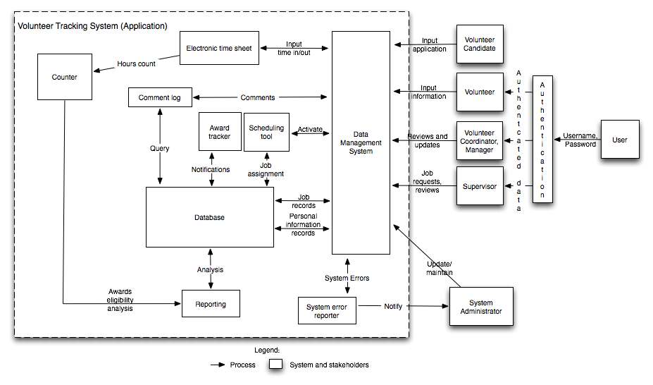
Figure 5: Element Relationship Diagram of Volunteer Tracking System
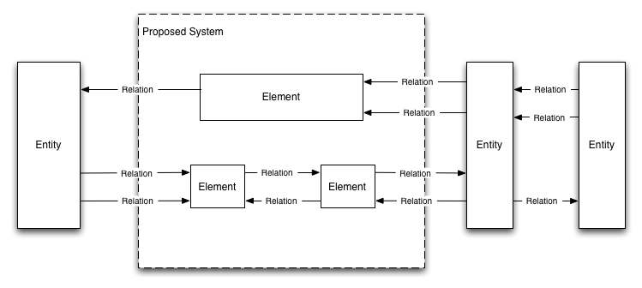
Figure 6: Element Relationship Diagram

Business Workflows
<< Characterize the new operational concept in terms of the flow of works through the proposed new system. The workflows will be illustrated in the form of business activity diagram(s). It will show the overview of the business activities flowing in proposed new system. As appropriate, indicate future capabilities of the new system or major differences from the current system as well. >>
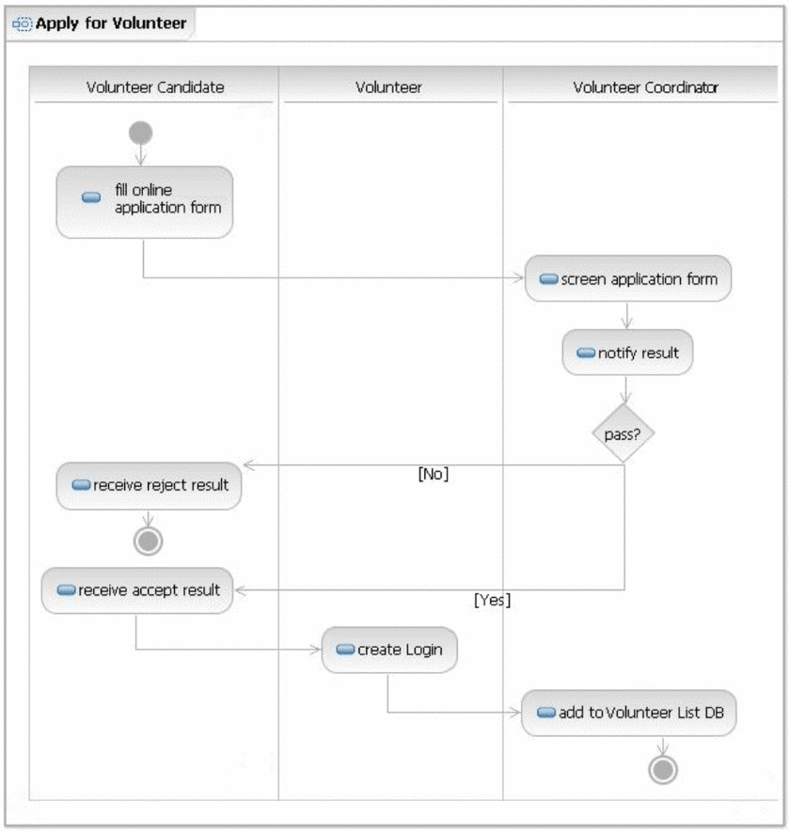
Figure 7: Business Workflow Diagram of Volunteer Tracking System

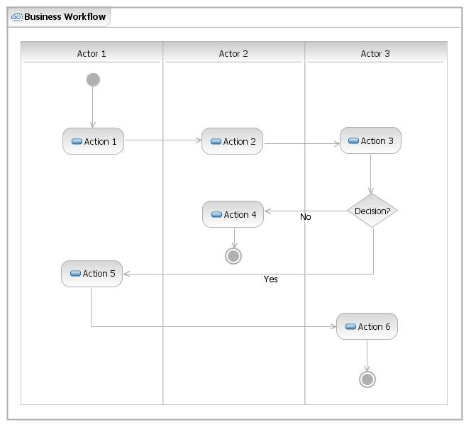
Figure 8: Business Workflows Diagram

Organizational and Operational Implications

Organizational Transformations
<< Identify and describe any significant changes in organizational structure, authority, roles, and responsibilities that will result from transitioning to the new system. Identify the major operational stakeholders affected by the changes, and indicate their concurrence with the changes.
Examples of organizational transformations:
- The need to hire a new system maintainer to take care of the system
- The elimination of the need for current, time-consuming management approvals before initiating delivery actions >>

Operational Transformations
<< Identify any significant changes in operational procedures and workflows that will result from transitioning to the new system. Identify major operational stakeholders affected by the changes, and indicate their concurrence with the changes.
Examples of operational transformations:
- Having the financial, delivery, and administrative processing concurrently progress rather than sequentially to decrease response time, subject to the check for payment validity before shipping an order.
- The option for new potential volunteers to fill out the applications online, or on paper and submitted in person. >>

